Add Partner Logo Here

Our local Whole Cities Community First Grant partner, *partner name*, is looking for volunteers!

***Describe what the volunteers would be doing in this section along with the number of volunteers needed and anything volunteers would be asked to bring/wear.***

**Volunteer Shift Date and Time Range**

**Volunteer Location Address**

***(Insert photo of the work in action if possible!)***

Contact *_partner* *name*__ at _*contact info*_ to sign up!

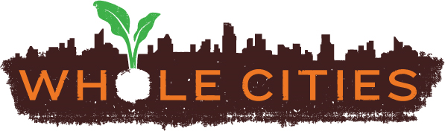

Scan the QR code to learn more about local nonprofit partners

